**DAILY ONLINE ACTIVITIES SUMMARY**

|  |  |  |  |  |  |  |  |  |
| --- | --- | --- | --- | --- | --- | --- | --- | --- |
| **Date:** | 01-07-2020 | | | | | **Name:** | Anvitha H M | |
| **Sem & Sec** | 4th ‘A’ | | | | | **USN:** | 4AL18CS010 | |
| **Online Test Summary** | | | | | | | | |
| **Subject** | | N/A | | | | | | |
| **Max. Marks** | | 30 | | **Score** | | | - | |
| **Certification Course Summary** | | | | | | | | |
| **Course** | Statistical methods for decision making. | | | | | | | |
| **Certificate Provider** | | | Great learning academy | | **Duration** | | | 7.5 hours |
| **Coding Challenges** | | | | | | | | |
| **Problem Statement:** C program to merge two sorted linked list. | | | | | | | | |
| **Status:** Executed | | | | | | | | |
| **Uploaded the report in Github** | | | | | YES | | | |
| **If yes Repository name** | | | | | <https://github.com/alvas-education-foundation/Anvitha-H-M> | | | |
| **Uploaded the report in slack** | | | | | Yes | | | |

**Online test:**

N/A

**Certification course:**

Statistical methods for decision making.

The course includes detailed explanation on basics of probability distribution, Poison’s distribution and normal distribution.

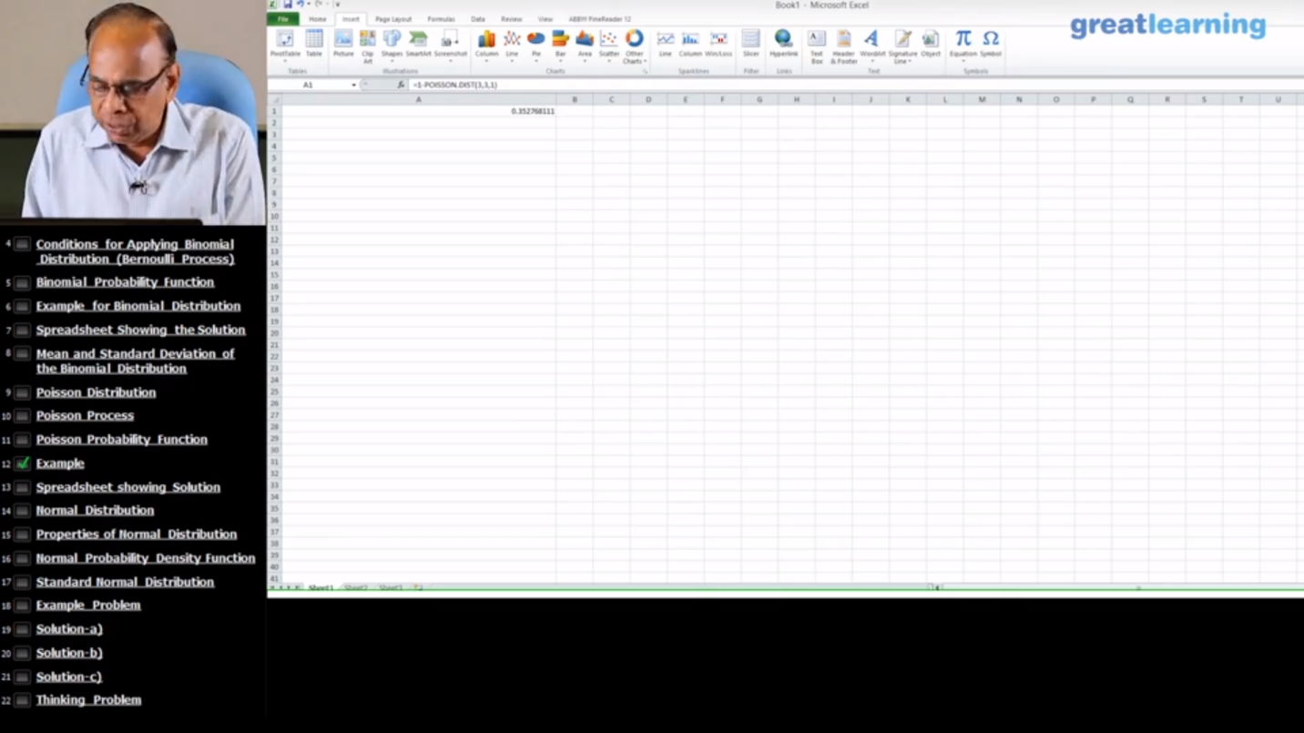

Online coding challenge

The programing statement of the day is

“C program to merge two sorted linked list.”

Solution: Executed and uploaded in Github repository.

Link: <https://github.com/alvas-education-foundation/Anvitha-H-M>

